Project Charter
Date: 05/12/2020

Prepared By: Manisha Mengani

Project Title: Mabel Cook Recruitment and Visitors Center

Project Start Date: 05/12/2020 Projected Finish Date: 06/04/2020

Budget Information:
The project would cost $ 2,273,905 million dollars for completion which include costs of Infrastructure, Cloud storage, Employee perks, Software Licenses.

Initiating Cost: $ 80,186
Planning Cost: $ 80,000
Executing Cost: $ 1,692,000
Monitoring and Controlling: $ 135,000
Closing: $ 80,000

Project Manager: Ravi Teja Pagidoju, +1 314-736-8586, S538296@nwmissouri.edu

Project Objectives:
The project helps in developing a mobile application that will track staff both in and out of the center through GPS, store student information for recruiters, and clock-in and clock-out information of their staff based on a digital clock for the Mabel Cook Recruitment and Visitors Center organization.
Success Criteria:
- Requirements should be clear.
- Project should calculate the budget correctly and must be able to able to complete within it.
- Project should estimate the proper time duration for deliverables and should be delivered without any delay.
- Technology must be selected wisely and should adhere to the same till the end.
- Project should abide by the Service level Agreement and should deliver the deliverables in time without any penalty.
- Efficient employees must be assigned to accomplish the tasks.
Approach:
We will implement the Agile methodology for the project as it is more robust then the waterfall method.

Initial Phase:
We will build an architecture for the project.

Planning Phase:
We will choose the technologies that are appropriate for the mobile application, selecting resources which is a part of resource management, budget estimation which is a part of cost management, estimation of time for the project completion. All these details are documented as a service level agreement which is signed by project manager and the client.

Execution Phase:
The entire application is segregated into various sections and assign the tasks to the team members accordingly. Scrum meetings would be conducted to monitor the progress of the project. Sprint meetings are conducted once in a month to know the status of the module which is a part of schedule management. This is a longest phase where the entire project deliverables are completed.

Monitor and control phase:
All the project deliverables are deployed and the application is made available to the client. The project is monitored continuously and controlled based on the input requirements by the client if any.

Roles and Responsibilities
Name and Signature | Role | Position | Contact Information
Ravi Teja Pagidoju  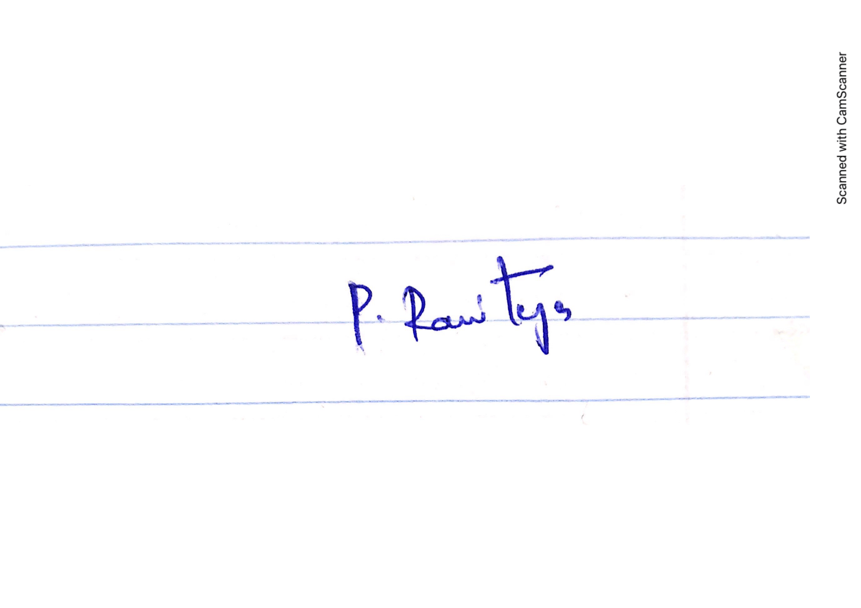 | Project Manager | Manager | S538296@nwmissouri.edu  +1 314-736-8586
Bhavya Deepthi Gorrepati  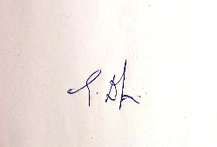 | Team Lead | Lead | S536778@nwmissouri.edu +1 660-528-0896
Sai Naveen Bhargava Gajavalli  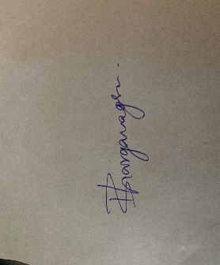 | Team Member | Developer | S536975@nwmissouri.edu  +1 660-528-0748
Pruthvi Naskanti  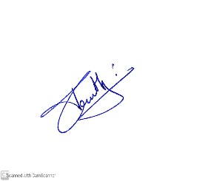 | Team Member | UI Developer | S538094@nwmissouri.edu  +1 913-424-0864
Manisha Mengani  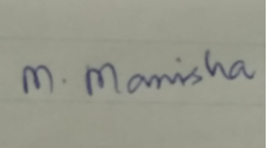 | Team Member | Tester | S537360@nwmissouri.edu  +1 660-528-0928
Comments: (Handwritten or typed comments from above stakeholders, if applicable)
N/A

